**Dr. D.Y. Patil Pratishthan's**

**Institute for Advanced Computing and Software Development**

**(IACSD), Akurdi, Pune.**

**Assignments and their Solution’s**

**Web Programming Technologies**

**Name of Candidate:- Prathamesh Raut.**

**PRN No.:- 210541281144** **Roll no.:- 1154**

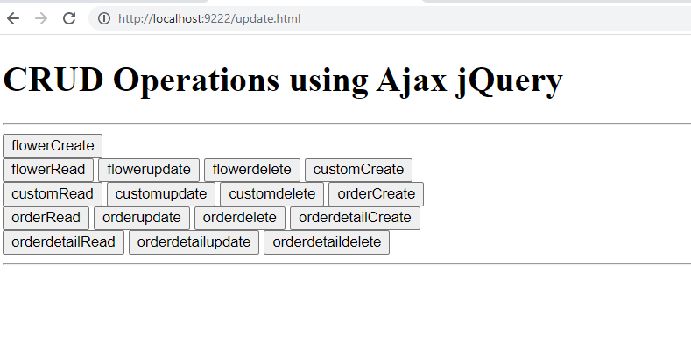

Flower table :-

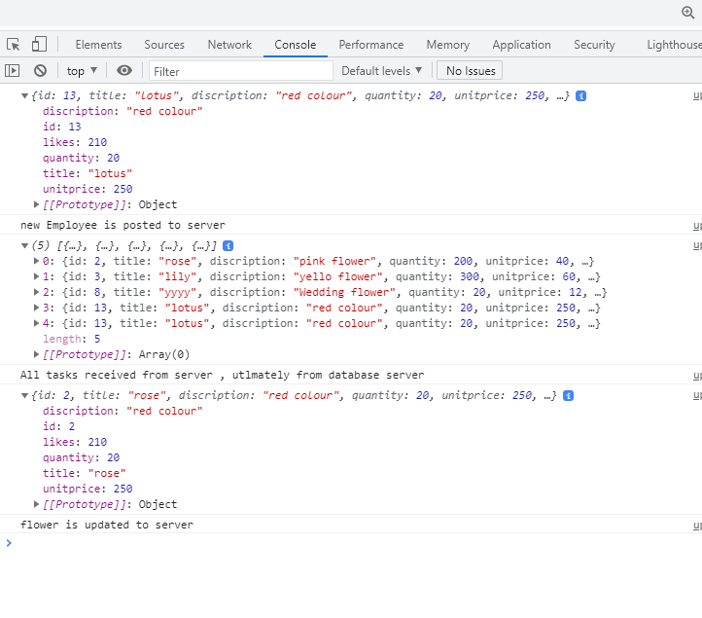

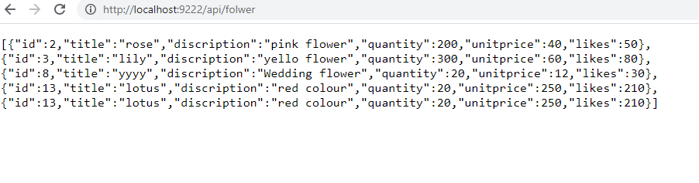

Customer table:

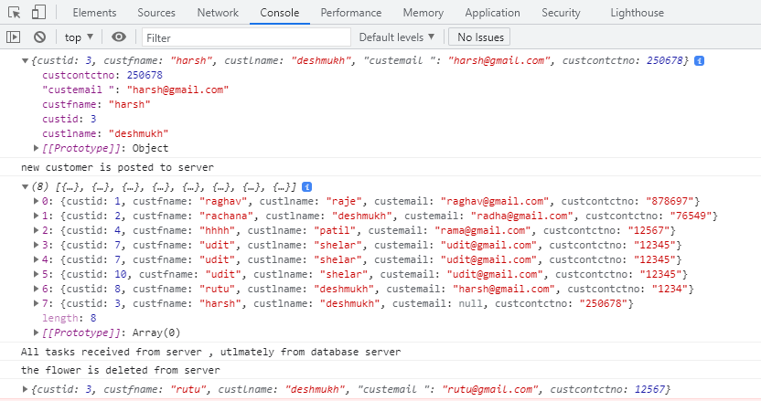

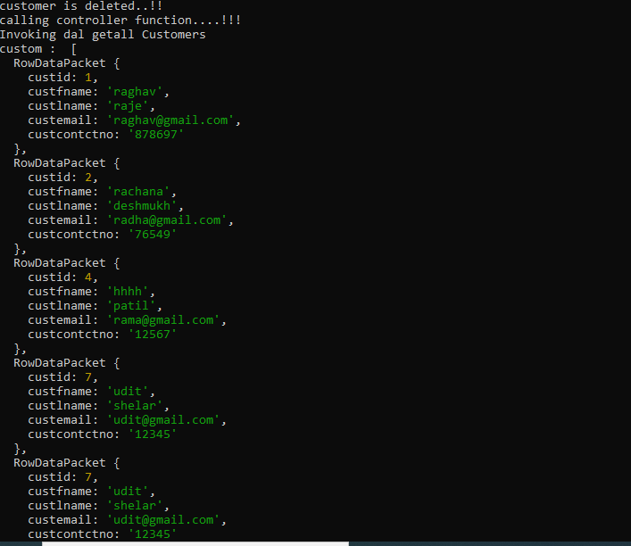

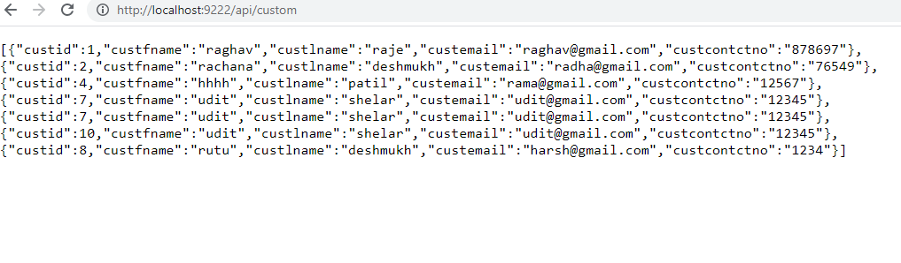

Order table:-

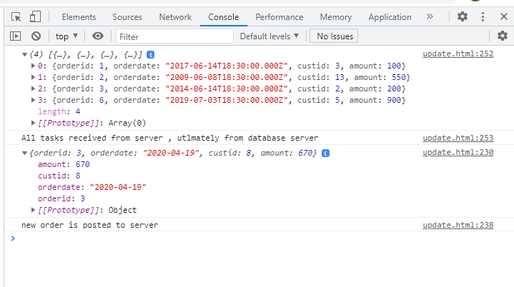

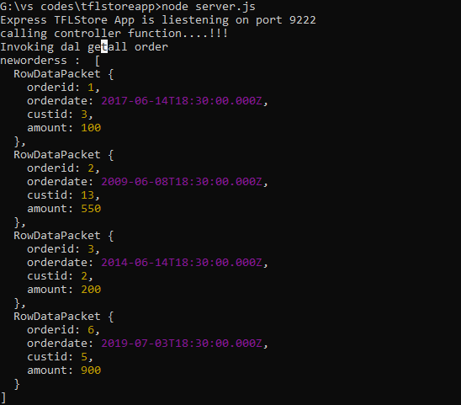

Orderdetail table:-

